Spooky Intention at a Distance
Is Your Mind More Powerful Than a Chick’s?



Eric Egan
10 min read
·
Feb 14, 2022
5

It moves away, taking all happiness with it. Darkness and despair are its wake. Trapped in darkness, a tiny heart and mind cry out for the tin brain to return with the only light — and it did.
Would you say you have more mental abilities than a chick or less?
Not that kind of chick.
This kind.
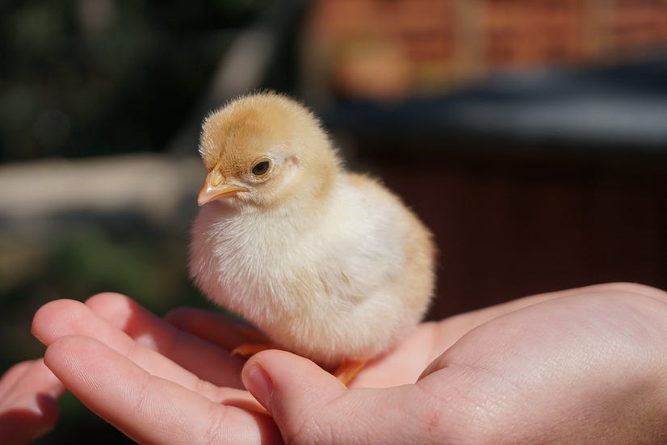
Photo by Afra Ramió on Unsplash
Remember your answer.
The First Study: Look Mom, No Hands!
One study involves chicks and a Roomba. Well, it wasn’t really a Roomba. The researchers called their little robot a “Tychoscope,” but it sounds like the first Roomba to me. They wanted to know if a chick could use Psychokinetic Action¹ (affecting things with only the mind) to control the Tychoscope.
The scientists described the Tychoscope 1 as “a small, self-propelled robot driven by an internal random generator to move about on a level surface in successive segments of random length and orientation.” ² (Sound like a Roomba to you?) It also had a marker to plot its travels on the paper lining the test area.
The Tychoscopes could not vacuum like a Roomba. However, one Tychoscope did have something on top the chicks wanted that no Roomba ever had. But that was in the second experiment. We will get to that in a bit. The first experiment involved love and the Tychoscope 1.
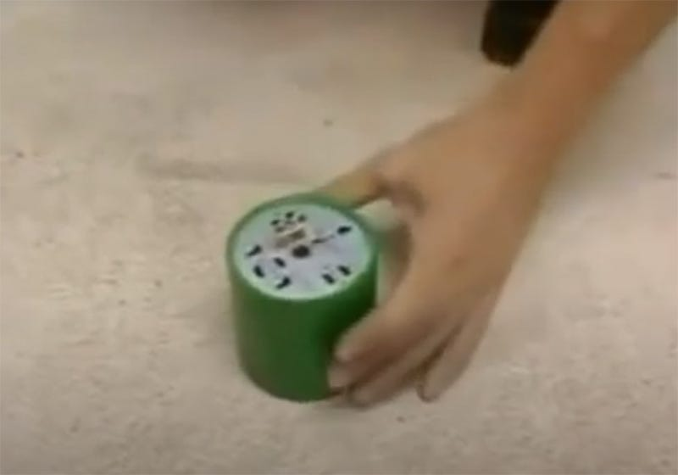
The little Tychoscope 1. (Pic from the video https://youtu.be/_AcmQB30krs)
The first experiment involved imprinting chicks to think the Tychoscope was their mother. “Newly hatched chicks memorize the characteristics of the first moving object they encounter, and subsequently show a preference for it.” ³
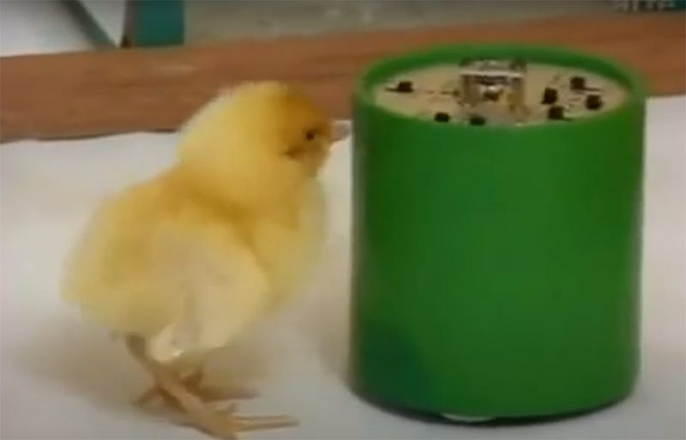
Chick following the Tychoscope 1. (Pic from the video https://youtu.be/_AcmQB30krs)
Once the chick was imprinted to think the Tychoscope was mommy, they put the chick in a clear cage next to a frame the size of a dining room table where the Tychoscope could move freely like so.
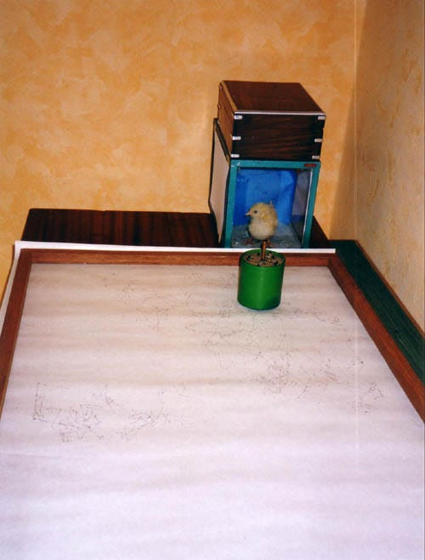
Imprinted chick in a clear cage next to a paper-lined frame the size of a dining room table where the Tychoscope could move freely. (http://gerp.free.fr)
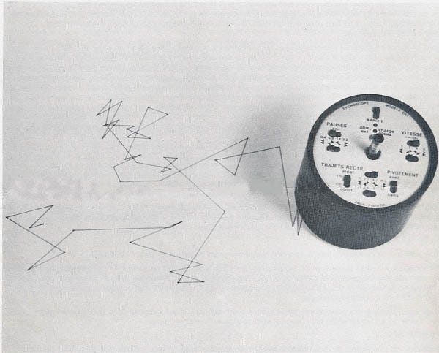
Tychoscope randomly plotting on the paper. You can see the marker just drops down a hole in the middle. (http://gerp.free.fr/Tycho2.jpg)
With no chick present or a chick that was not imprinted, the Tychoscope went equally on all sides of the pen. When there was an imprinted chick present, “It was found that the Tychoscope spent two and a half times longer on the half of the surface closer to the chicks, compared to its motion when the cage was empty.” ²
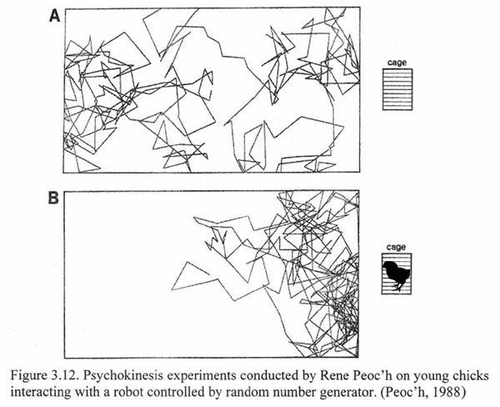
A YouTube video about the first experiment with the Tychoscope 1. The video is in French. However, you can change the close caption to auto translate to your preferred language.
Study II, Let There Be Light!
The second study used a second-generation robot, the Tychoscope 2. The Tychoscope 2 is larger and radio-controlled by a computer. The direction of the Tychoscope 2 was determined by a random number generator that is “based upon microelectronic noise associated with thermal electron motion at a conducting interface.” ² It is a fancy way of saying it is a computerized version of flipping a coin.
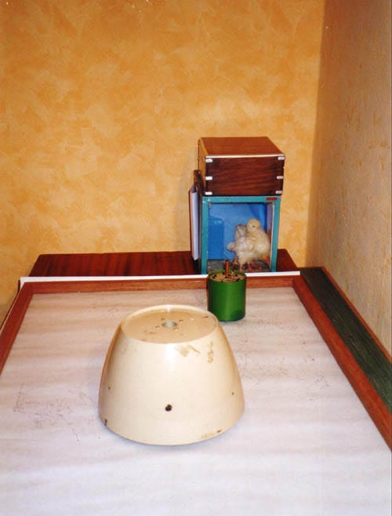
The larger Tychoscope 2 in front of the smaller green Tychoscope 1. http://gerp.free.fr/tycho%201%20et%20tycho%202r.jpg
Results
Get this! They did 80 experiments with chicks and 100 control experiments without any chicks or any observer. “In 57 out of 80 of the chick experiments, (71 %) the robot spent more time in the chick half of its range.” ²
Guess what side the chick was on…
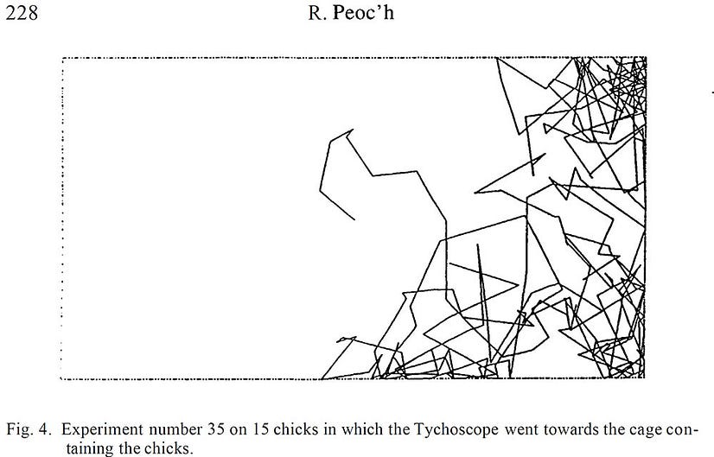
The cool thing is; they put the random generator part of the computer in a “Faraday box.” ⁴ That box will block all electromagnetic fields, aka; radio signals. If your cell phone was in a Faraday box, even next to a cell tower, it would have 0 signal bars. Your cellphone could not send or receive anything.
This second study did not use imprinted chicks. It used the chick’s desire for light. The only light in a dark room was a candle on top of the Tychoscope 2.
The researchers said, “Specifically, we wanted to know whether chicks raised in darkness would be capable of pulling the light-bearing Tychoscope towards them to have more luminosity, since they do not like to be in darkness during the day.” ²
Another exciting thing was when the chicks wanted to sleep, they “seemed to push the Tychoscope away.” ² During daylight hours, the chicks caused the Tychoscope (their only light source) to be near them most of the time. When the chicks wanted to sleep, they caused the Tychoscope to be away from them, darkening their side of the area. This indicates that the chick’s intention can attract or repel.
It Gets Even More Strange
They did the same experiment again with one change. Researchers moved the computer controlling the Tychoscope 2, 23k (14 miles) away, and they got the same results!
“…the fact that psychokinesis can occur independently of distance or of the localization of the target is of great importance.” ⁵ The researchers also said, “…the phenomenon shown is probably long-distance psychokinesis.” ⁵
Albert Einstein called quantum entanglement “spooky action at a distance.” This is because communication between two particles is instant, as in faster than the speed of light. “Spooky” because Einstein did not understand how anything could go faster than the speed of light. Scientists still do not know how quantum entanglement works any more than how these chicks control the Tychoscopes.
The day science begins to study non-physical phenomena, it will make more progress in one decade than in all the previous centuries of its existence. -Nikola Tesla
What Does This Have To Do With You?
You do not have to wait for science to figure out how this works. The chicks did not need to know how the Tychoscope works to do this. It’s not magic. It’s one of the many less-known natural laws of the machine we live in. Or as Tesla calls it, “non-physical phenomena.”
The chicks were born with the ability to use this natural law the same as you were. The difference is you have learned how not to use it — taught this kind of natural power does not exist. Studies show that people that do not believe this is possible are right, for them anyway. More on that at the end.
To understand what the chicks knew, you must first understand what they did not know.
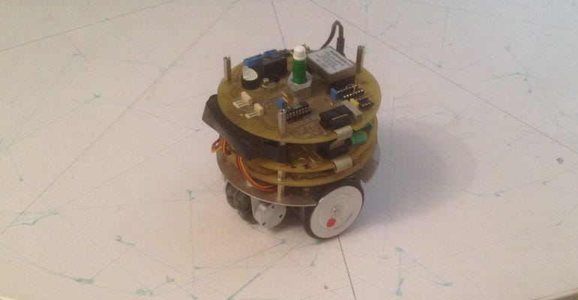
The inside of a Tychoscope 1 (metapsychique.org)
The chicks knew everything they needed to know about how the machine worked — nothing. The chicks knew everything they needed to know about how the natural law works to use it — nothing.
What do you need to know about how The Machine you live in works to use it? Nothing. Just that it does.

(www.123rf.com/profile_grandfailure)
It’s Not What You Think
Websters’ dictionary defines psychokinesis as the “movement of physical objects by the mind without the use of physical means.” This definition is what most people believe; moving stuff with your mind. This definition is not accurate for what these chicks did.
When driving your car down the freeway, are you moving thousands of pounds of steel down the road at high speed? At first, you may think yes. But like the definition above, not exactly. No human body has the strength to do what your car does. Your car has a power source you know how to use. You do not need to know how your car’s power source works. You only need to know how to work it, right?
In other words, the chicks did not directly influence the Tychoscopes with their mind the way it appears — the way most people think. A natural law of the machine we live in is the source of the power they worked with. The chicks did not do any of the work that caused the machines to go where intended. No more than your physical body has the power to move a 5,000lb car 75mph down the freeway.
The chicks accessed the natural power of the machine we live in. A powerful middleman is what moved the Tychoscope for the chicks. You use a more primitive method of shifters and the gas pedal to access the power that moves your car. Your car’s engine, your middleman, moves your car for you.
That is why the chick’s intention was still carried out even when the machine’s controls were in a shielded Faraday box 14 miles away. The chicks had nothing to do with directly moving the Tychoscopes. The chicks only dealt with the powerful “middleman” mentioned above. Call it natural law or source energy or whatever you want. It has acquired many names over 1,000s of years: Lifeforce, prana, Islamic and Sufic rūḥ, Latin Anima, Greek pneuma, Chinese qi, Polynesian mana, Amerindian orenda, German od, Hebrew ruah, The Way in the Tao Te Ching, and many more.
Why Does It Matter if the Chicks Use Psychokinesis As It Is Commonly Defined or Not?
Because if the chicks only use their mind, they would be limited by their mind. Their mind is only a part of the infinite power everything is connected to.
The chicks only intended to have happiness; for “mommy” or the light to move as intended. They let the natural laws work out all the details for their happiness. “Let” is a powerful word. Letting go of how your intention gets done is the nearly impossible part. The chicks accessed the same unlimited natural power you have access to. It is that simple.
Simple? YES! Easy? NO!
Here is a key. How your intention happens is not your area. In fact, if you work on the “how” and try to do-it-your-way, you will limit the number of ways your intention can happen from infinity to what your mega-mind can think of. Also known as the hard way — rowing your boat upstream. Stay out of how it should happen, let go, and row your boat gently down the stream because life is but a dream. Simple, right?
How to use these little-understood natural laws is too simple for most people to figure out. All you have to do is, have an intention, know it works…..and do nothing? Yes. That simple and almost impossible task. Letting go is difficult. Don’t be hard on yourself. It was hard for one of the most famous experts on letting go thousands of years ago too.
The 2,500-year-old Tao Te Ching (Dao De Jing) chapter 37 is about the difficulty of letting your intention happen on its own. It is about what these chicks were not doing. To be clear, I am not saying these natural laws are about Taoism. Taoism is about these older natural laws.
I am saying you have something in common with the writer of the Tao Te Ching, Lao Tzu (Laozi). I will translate chapter 37 for you after the original. The Tao Te Ching is amazing, but the first time you read it you will say “WTF?” a lot.
First, The Original Translation of Chapter 37.
“The Tao in its regular course does nothing for the sake of doing it, and so there is nothing which it does not do.
If princes and kings were able to maintain it, all things would of themselves be transformed by them.
If this transformation became to me an object of desire, I would express the desire by the nameless Simplicity.
Simplicity without a name
Is free from all external aim.
With no desire, at rest and still,
All things go right as of their will.”
— Translated by James Legge, 1891
My Translation.
If you let go and put no effort into how intention gets done, it leaves nothing undone.
If rulers let go of trying to control everything, all things would work themselves out.
When you lose faith and start trying to make your intention happen your way, remember to let go and let nameless simplicity do the work.
Simplicity without a name
Is free from all external aim.
With no desire, at rest and still,
All things go right as of their will.”
Even the great Lao Tzu, the famous writer of Tao Te Ching, did not find letting go simple either. You hear his failure to let go when he said, “If this transformation became to me an object of desire….” He would catch himself and let go again with… “would express the desire by the nameless Simplicity.”
I think Lao Tzu came up with the four lines at the end to help him when he was stressing and having trouble letting go. He probably said it over and over when his ego would not STFU.
Your ego will keep distracting you with BS you can’t do anything about too. But like any workout, as you practice letting go of HOW your intention will happen and let the “nameless simplicity” do the work, you will get better and stronger — at doing nothing.
Learning to let go and let the natural laws handle how your intentions happen has been a lifelong learning process for thousands of years for the few that have tried.
Do You Remember Your Answer?
Is Your Mind More Powerful Than a Chick’s? Hopefully, your answer is yes. Because many interesting studies show; what you believe about non-physical phenomena determines if you can access it — or not.
Seriously, if a one-week-old chick can access it, you can too.
Want To Get Lucky?
What does using non-physical phenomena to your advantage, luck, look like? Find out and see if you are a sheep or a goat in my article, May the Odds Be Ever in Your Favor: The Secret of Luck.
Keep seeking, my friend.
Join my newsletter learn.thescienceofdestiny.com.
Want to read thousands of great articles? Then join Medium.com with my affiliate link.
References
[¹]: Movement of physical objects by the mind without use of physical means. https://www.merriam-webster.com/dictionary/psychokinetic
[²]: Peoc’h, R. (1995). Psychokinetic Action of Young Chicks on the Path of An Illuminated Source. In Society for Scientific Exploration: Vol. 9. Journal of Scientific Exploration.
[³]: Nakamori T, Maekawa F, Sato K, Tanaka K, Ohki-Hamazaki H. Neural basis of imprinting behavior in chicks. Dev Growth Differ. 2013 Jan;55(1):198–206. doi: 10.1111/dgd.12028. PMID: 23294362.

